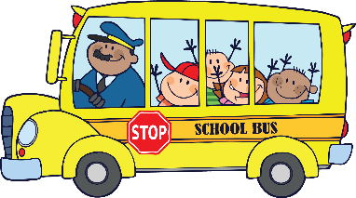School Bus

|  |  |  |
| --- | --- | --- |
| **Be Respectful** | **Be Respectful** | **Be Respectful** |
| Listen to driver  and monitor. | Use a quiet voice. | Use kind words. |